**Are accidents more severe in certain locations based on Latitude?**

* There is no correlation between severity of an accident and location. One is just as likely to get in a severe accident regardless of location.

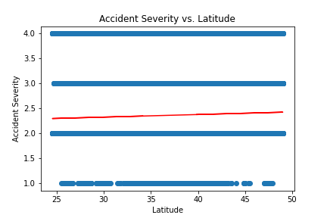

**Do more accidents happen in more populated areas of the US?**

* There are more accidents in the states with higher populations. The only anomaly is SC, which has a medium population (number 23 overall) but is in the top 6 for number of accidents.

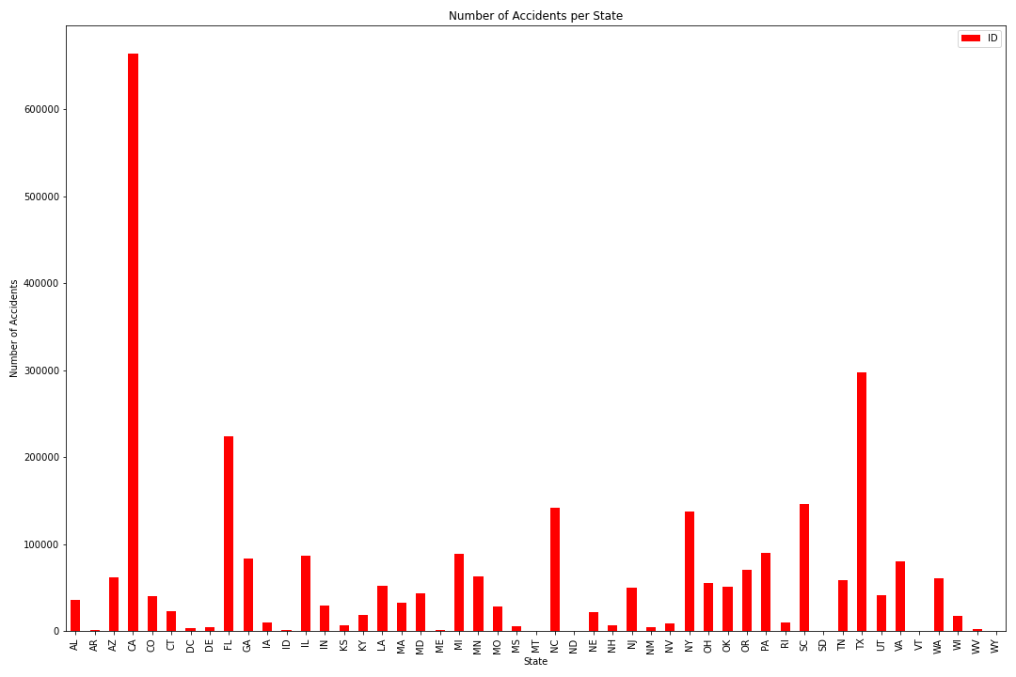

* There are more accidents in the eastern time zone than anywhere else. My assumption is due to more dense population. Ultimately, the more populated time zones have the more accidents.

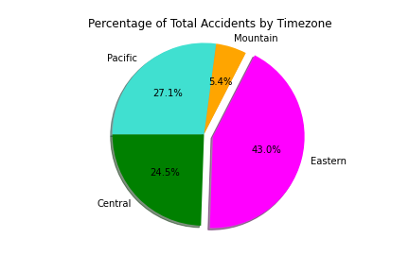

* Based on the heatmap, there is much less density of accidents in the lower populated mid and mid-west states. The east and west coasts are more populated areas, and have a higher number of accidents. Also, there appear to be a high number of accidents on the cross-country interstates such as I-80.

